Religious Education

In R.E., we grow in faith, explore beliefs, and learn to live with hope and purpose.

Curriculum Intent

In Religious Education, we aim to enable all pupils to grow in faith, explore a range of religious and non-religious worldviews, and learn to live with hope and purpose. Rooted in the school’s Christian vision, our curriculum is designed to develop pupils’ spiritual, moral, social, and cultural understanding through engagement with challenging questions about meaning, belief, and values.

Pupils are encouraged to think critically, reflect deeply, and respond thoughtfully to the beliefs and practices of others. Through this process, they build resilience, empathy, and a sense of aspiration grounded in the love and teachings of Jesus Christ. The R.E. curriculum equips pupils with the knowledge, skills, and understanding to make informed choices, contribute positively to their communities, and live out the school’s vision to be the best they can be.

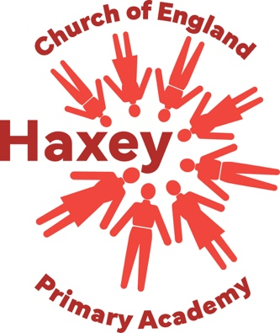
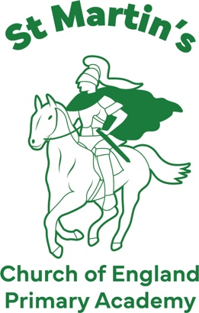
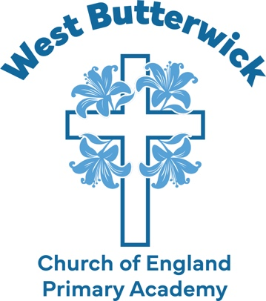

Vision
Developing hope & resilience • Building a community of aspiration
Inspired by the love & teachings of Jesus Christ to be the best that we can be

Values
Hope Love Courage Resilience Respect Wisdom

