History National Curriculum Statements:  - Events beyond living memory that are significant nationally or globally. (eg. The Great Fire of London.  - The lives of significant individuals in the past. (Samuel Pepys and Christopher Wren) | What I already need to know:  - That some significant event in history happened a long time ago, before myself, my parents or my grandparents were alive. (Y1)  - That when my parents and grandparents were growing up some aspects of their lives would have been different to mine. (FS2 and Y1)  - That a timeline is where things are put in the order that they happened. (Y1)
I am going to learn to:
History
Investigate and interpret the past
- Ask questions about what it was like for people living in 1666 compared to today.
- Ask questions and investigate why the fire spread so rapidly.
- Use different sources of information to answer questions about The Great Fire of London.
- Understand why some sources of information are more reliable than others.
- Understand what it was like at the height of the fire.
Build an overview of world history
- Understand the reasons why people acted like they did.
- Understand the importance of Thomas Farrinor, Samuel Pepys, King Charles ll and Sir Christopher Wren.
Understand chronology
- Understand and sequence the main events of The Great Fire of London by creating a timeline.
- Write a chronological newspaper article based on the main events of The Great Fire of London.
Communicate historically
- Compare The Great Fire of London to The Great Fire of Haxey using vocabulary such as years, centuries.

Cross-Curricular Links: Art & English
- Using painting and collage skills to create a scene from The Great Fire of London.
- Writing descriptions of the fire and newspaper articles.

Key Vocabulary:
London, diary, architect, chronological, eye witness, flammable, Samuel Pepys, Thomas Farrinor, King Charles ll and Sir Christopher Wren.

Facts I will find useful:

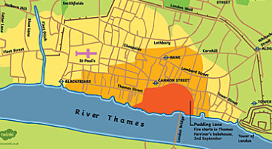

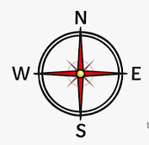
Things to look forward to:
- Creating a collage showing The Great Fire of London raging.
- Learning about The Great Fire of London on the IPADS and playing a game to help put out the fire and pull the houses down to create a fire break.



