
Y1 – Geography – Countries of the UK

National Curriculum Statements:  - Name, locate and identify characteristics of the four countries and capital cities of the United Kingdom and its surrounding seas.  - Use world maps, atlases and globes to identify the United Kingdom and its countries. | Things I need to know already:  - Awareness of the features of the immediate environment and how environments might vary from one another.
I am going to learn to:  - Name the countries of the United Kingdom and locate them on a map.  - Name the capital cities of the countries of the United Kingdom and locate them on a map.  - Name the seas that surround the United Kingdom and locate them on a map.  - Locate the United Kingdom on a world map.  Things to look forward to:  - Finding where I live on a map of the United Kingdom and a map of the world.  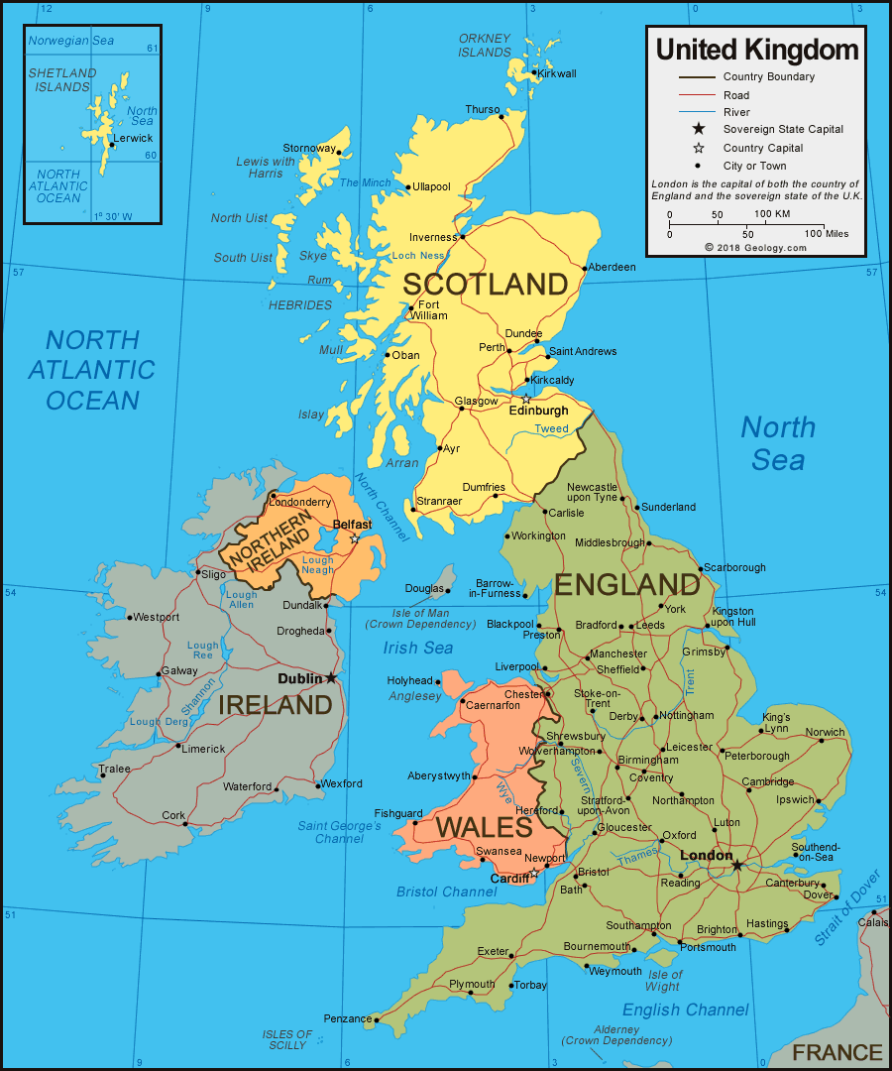 | Facts I might find useful:  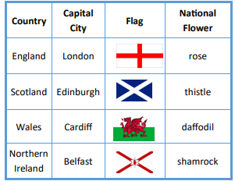
  Vocabulary
  United Kingdom | The country we live in, which includes England, Scotland, Wales and Northern Ireland.
  Capital city | The city where the government sits.
  Country | An area of land that is controlled by its own government.
  Flag | A piece of cloth that can be attached to a pole and is used as a symbol of a particular country.
  London | The capital city of the United Kingdom.
  Sea | A large area of salty water.
  Island | A piece of land that it completely surrounded by sea.

Y1 – History and Geography – Explorers/Hot and Cold Areas of the World

National Curriculum Statements:  - Develop an awareness of the past, using common words and phrases relating to the passing of time.  - The lives of significant individuals in the past who have contributed to national and international achievements.  - Name and locate the world’s seven continents and five oceans.  - Use world maps, atlases and globes to identify countries, continents and oceans.  - Identify the location of hot and cold areas of the world.  - Use simple compass directions. | Things I need to know already:  - Be able to talk about past and present in their own lives and the lives of family members.  - Know about similarities and differences in relation to places.  - Talk about the immediate environment and how environments might vary from each other.
I am going to learn to:  - Retell the story of how Ernest Shackleton attempted to cross Antarctica.  - Describe how Neil Armstrong became the first man on the moon.  - Describe how astronauts live in space.  - Identify the Arctic and Antarctic on a map and globe.  - Differences and similarities between hot and cold areas of the world and the animals that live there.  - Identify the main compass points.  Things to look forward to:  - Space Day  - Watching videos of astronauts on the International Space Station.  - Space role play area.  - Finding out about the different animals that live in different parts of the world. | Facts I might find useful:  - The Antarctic is very cold and snowy.  - There is no gravity in space, so things float around.  - Ernest Shackleton attempted to cross Antarctica in 1914.  - Neil Armstrong landed on the moon in 1969.  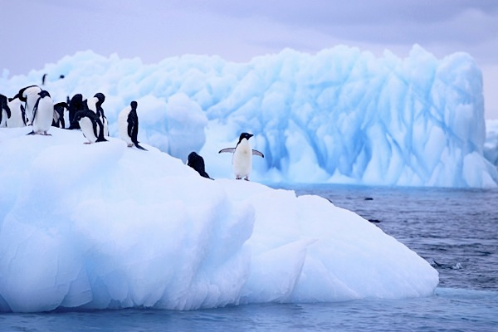
  Vocabulary
  Antarctic | The area around the South Pole.
  astronaut | A person who travels into space.
  gravity | The force which keeps us on the ground.

Y1 – History and Geography - Seaside Holidays/The Seaside

National Curriculum Statements:  - Develop an awareness of the past, using common words and phrases relating to the passing of time.  - Changes within living memory.  - Use basic geographical vocabulary to refer to key physical and human features. | Things I need to know already:  - Be able to talk about past and present in their own lives and the lives of family members.  - Know about similarities and differences in relation to places.  - Talk about the immediate environment and how environments might vary from each other.
I am going to learn to:  - Describe what seaside holidays are like now.  - Describe what seaside holidays were like in the past.  - Compare what is similar and what is different between seaside holidays now and in the past.  - Consider where people go to for seaside holidays in Britain.  - Consider physical and human features of the seaside.  - Describe similarities and differences between Haxey and the seaside.  Things to look forward to:  - Visit to Cleethorpes.  - Playing beach games. | Facts I might find useful:  - Rich people started visiting the seaside about 200 years ago.  - Seaside holidays became possible for many people about 150 years ago when steam trains were invented.  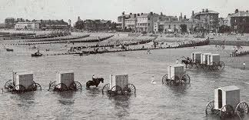
  Vocabulary
  Time line | Ordering objects and events from earliest to latest.
  Bathing machines | Huts used by Victorian bathers so they could change in private.
  Punch and Judy | A puppet show that has been common since Victorian times.
  Pier | A structure for people to walk along that is built out into the sea.
  Cliff | A steep rock face close to the edge of the sea.
  Harbour | A place by the seaside where boats can stay safely in the water.
  Dunes | Hills or mounds of sand held together by plants, often near the sea.

