
Year 2 – Geography – Our Park

Geography National Curriculum Statements:  Place knowledge  - Understanding geographical similarities and differences through studying the human and physical geography of a small area of the United Kingdom, and of a small area of contrasting non-European country.  Human and physical geography  - Use basic geographical vocabulary to refer to key physical features and key human features.  Geographical skills and fieldwork:  - Use simple compass direction (North, South, East and West) and locational and directional language (eg. near, far, left and right) to describe the location of features on a map. | What I already need to know:  - The countries and capital cities that make up the United Kingdom.(Y1)  - How to use world maps, atlases and globe to find the United Kingdom and its counties.(Y1)  - About the human and physical feature of the school grounds. (Y1)  - How to observe the seasons and daily weather patterns in the United Kingdom. (FS2 and Y1)

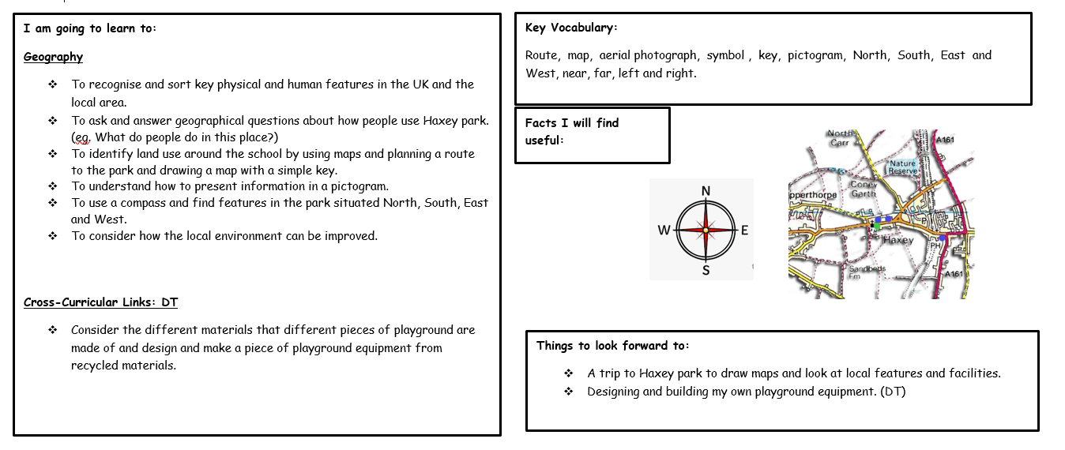
Year 2 – Geography – Around the World

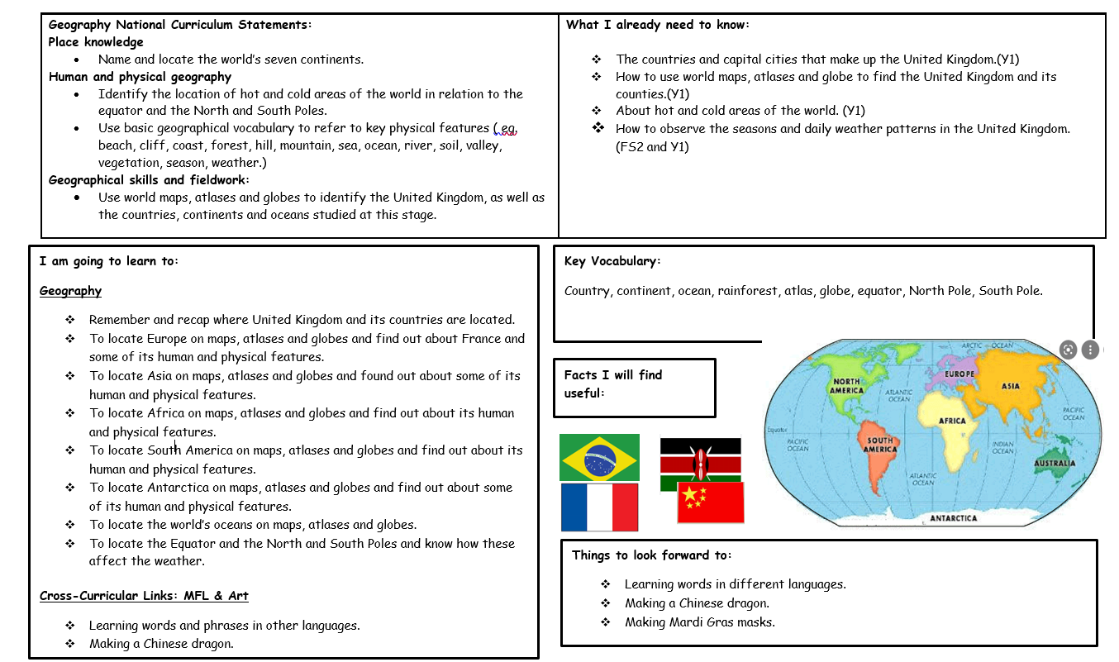

Year 2 – Geography – Australia



