
Year 3 – Geography – Locational Features, Settlements and Geographical Skills
National Curriculum Statements:  - name and locate counties and cities of the United Kingdom, geographical regions and their identifying human and physical characteristics.  - Use symbols to locate human and physical features on a map.  - Types of settlement and land use (Stone Age) natural resources.  - Use maps – map our road safety route  - Use points four points of a compass to locate  - Use symbols and keys | What I already need to know:  - What the points North, South, East and West are on a compass.  - Use simple compass directions.  - Use simple directional language i.e. near,far,left,right.  - The name and location of the countries and capital cities of the UK.
Key Vocabulary:
Physcial feature
Human feature
Country
County
City
Settlement

I am going to learn to:
- I can use the four points of compass to describe the location of the countries and cities of the UK.
- I can name some of the counties of the UK.
- I can use a map to name and locate counties and cities of the UK.
- I can name and locate areas of high ground in the UK.
- I can use a map or atlas to locate areas of high ground in the UK.
- I can describe and understand types of settlement and land use.
- To create a map of our route for our road safety lessons.

- Geographical skills and fieldwork

Facts I will find useful:
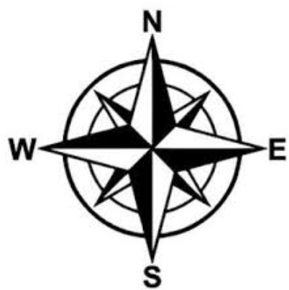
Things to look forward to:
Researching Stone Age settlements, and discover what was left behind that gives us a glimpse of the past.
Creating a road safety route.

Year 3 – Geography – Mountains, Volcanoes, Earthquakes and Tsunamis

What I already need to know:
I am going to learn:
Volcanoes
• Volcanoes are made when pressure builds up inside the earth. This affects the earth’s crust causing magma to sometimes erupt through it.
• Active volcanoes have erupted in the last 10 000 years.
•Dormant volcanoes haven’t erupted in the last 10 000 years but may erupt again.
• Extinct volcanoes aren’t expected to erupt again.
Earthquakes
• Earthquakes are caused when the earth’s tectonic plates suddenly move.
• Most earthquakes occur near the tectonic plate boundaries.
• Earthquakes can cause lots of damage to roads, buildings and property.

National Curriculum Statements:
- Describe and understand key aspects of mountains, volcanoes and earthquakes.

I am going to learn:
Layers of soil
- That layers of soil are different and build up over many years…
 |  | Rotting dead leaves and animals
 | 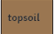 | Plant’s roots grow here. Very few rocks.
 | 
  Rocks and stones. Full of nutrients. Tree roots may reach. Fossils.
 |  | A mass of rocks. Fossils.

Layers of the Earth
- That the Earth is built up of different layers…
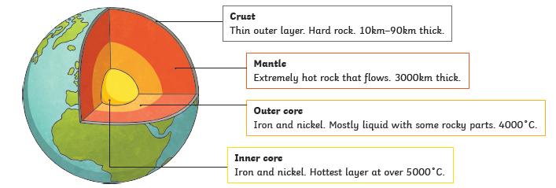

Tsunamis
• A tsunami is a giant wave caused by a huge earthquake under the ocean.
• The earthquake causes a large amount of water to be displaced very quickly causing a series of waves.
• As the waves travel through shallower water near land, they get bigger and bigger. The wave crashes onto the land causing devastation to buildings and sometimes even lives.
Mountains
- Name of some areas of high ground in the UK.
- Find areas of high ground on a map of the UK.
- Use a legend to find areas of high ground on a map.
- Find the height of a peak on a map.

Tornadoes
• A tornado is a swirling funnel of air that forms when warm air rises from near the ground into big cumulonimbus clouds.
• There can be thunder and lightning at the same time.
• You can see tornadoes due to the dust and water droplets caught
in the clouds.
• Storm chasers are film-makers and scientists who head towards
the storms. They film the tornadoes and collect data about them.
• Most tornadoes happen in Tornado Alley in America – more than
500 each year.
• Tornadoes can happen in the UK but only around 30 per year.

Key Vocabulary:
Active Cumulonimbus cloud
Dormant Erupt
Extinct Fossils
Magma Peak
Tectonic plates

Things to look forward to:

Making an erupting volcano

Making a playdough model of the layers of the Earth

Year 3 – Geography – Geographical Skills

National Curriculum Statements:  - name and locate counties and cities of the United Kingdom, geographical regions and their identifying human and physical characteristics.  - Use symbols to locate human and physical features on a map.  - Types of settlement and land use (Stone Age) natural resources.  - Use maps – map our road safety route  - Use points four points of a compass to locate  - Use symbols and keys | What I already need to know:  - What the points North, South, East and West are on a compass.  - Use simple compass directions.  - Use simple directional language i.e. near,far,left,right.  - The name and location of the countries and capital cities of the UK.
I am going to learn to:
- I can use the four points of compass to describe the location of the countries and cities of the UK.
- I can name some of the counties of the UK.
- I can use a map to name and locate counties and cities of the UK.
- I can name and locate areas of high ground in the UK.
- I can use a map or atlas to locate areas of high ground in the UK.
- I can describe and understand types of settlement and land use.
- To create a map of our route for our road safety lessons.

- Geographical skills and fieldwork

Key Vocabulary:
Physcial feature
Human feature
Country
County
City
Settlement

