

Knowledge Planner
Y4 – Greece
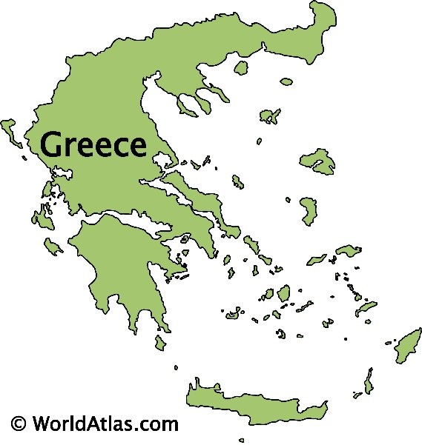
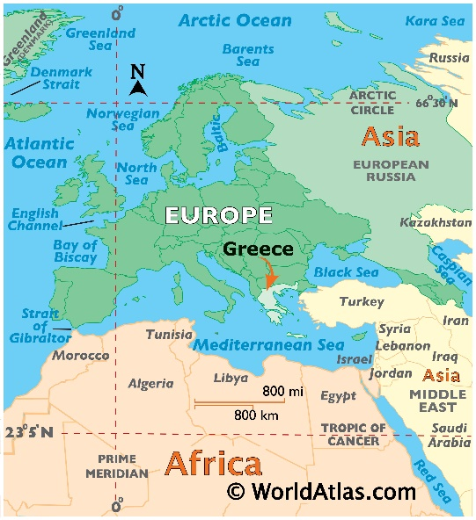
Facts I will find useful:
- Greece is a peninsular country, with approximately 3,000 islands.
- Greece has a landscape of forests, rivers, mountain ranges and beaches.
- The climate can range from hot and dry places to cold mountain forests, depending on the region and time of year.
- Many tourists visit Greece, especially Athens and the islands.
- Greece’s main exports include petrol and food, such as olive oil and fish.
- Greece has many ancient structures the Acropolis and the Delphi.
- Greece is a mountainous country with a very long coastline, made up by a mainland, peninsulas and islands.
- Greece's natural hazards include severe earthquakes, floods, droughts and wildfires. Current environmental issues include air pollution and water.
I am going to learn to:
- Use a map and atlas to find Greece and the Greek islands.
- Describe the locations of Haxey in the UK and Greece in Europe using the eight compass points.
- Study physical maps of Greece and label them to show the different regions. Use this knowledge to explain the land-use patterns of Greece.
- Explain how the human geography of Athens has changed over the years.
- Study tourism and migration patterns of Greece. Research which parts of Greece generate the most tourism and explain the reasons why.
- Analyse different types of maps and graphs that give us information about Greece, including climate maps. Look at graphs showing the climate for Greece.
- Study the Greek islands and explain why this means the Greeks were considered seafaring people.
- Create a Venn diagram to compare similarities and differences between Greece and North Lincolnshire and understand the reasons for these.

Things to look forward to:
- Use the internet to explore what Greece is like (contrast and compare)
- Look at Greek architecture and landscape.
- Look at Greece in relation to our history topic on Ancient Greece.
- Explore Greek art and make our own Greek artwork (Art and History links)
- Learn about special buildings in Athens, the capital city of Greece.
- Use a compass, globes and maps.
- Look at graphs to show the climate in Greece during different months.
What I already need to know:
- The village my school is in is called Haxey, which is in North Lincolnshire. There are villages and towns in North Lincolnshire, some of which are coastal.
- North Lincolnshire is in England, which is a country. England, which is in the United Kingdom, is in the continent of Europe.
- The seven continents (including Europe) and five oceans.
- Some land-use patterns of the UK.
- Some of the characteristics of another country in Europe.
- Some examples of natural hazards, including earthquakes.
National Curriculum Statements:
- Locate the world’s countries, using maps to focus on Europe (including the location of Russia) and North and South America, concentrating on their environmental regions, key physical and human characteristics, countries, and major cities.
- Identify the position and significance of latitude, longitude, Equator, Northern Hemisphere, Southern Hemisphere, the Tropics of Cancer and Capricorn, Arctic and Antarctic Circle, the Prime/Greenwich Meridian and time zones (including day and night).
- Use maps, atlases, globes and digital/computer mapping to locate countries and describe features studied
- Use the eight points of a compass symbols to build their knowledge of the United Kingdom and the wider world

Knowledge Planner
Y4 – All Around the World
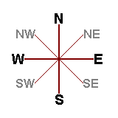
Facts I will find useful:
- Latitude lines are going horizontally and longitude vertically.
- The world has seven continents and five oceans.
- A compass can be used with 8 points.
What I already need to know:
- The village my school is in is called Haxey, which is in North Lincolnshire. There are villages and towns in North Lincolnshire, some of which are coastal.
- North Lincolnshire is in England, which is a country. England, which is in the United Kingdom, is in the continent of Europe.
- The seven continents (including Europe) and five oceans.
- Some land-use patterns of the UK.
- Some of the characteristics of another country in Europe.
- Some examples of natural hazards, including earthquakes.
- Use world maps, atlases and globes to identify the United Kingdom and its countries, as well as the countries, continents and oceans studied at this key stage.
- Use simple compass directions (North, South, East and West) and locational and directional language [for example, near and far; left and right], to describe the location of features and routes on a map.
National Curriculum Statements:
- Locate the world’s countries, using maps to focus on Europe (including the location of Russia), North, and South America, concentrating on their environmental regions, key physical and human characteristics, countries, and major cities.
- Identify the position and significance of latitude, longitude, Equator, Northern Hemisphere, Southern Hemisphere, the Tropics of Cancer and Capricorn, Arctic and Antarctic Circle, the Prime/Greenwich Meridian and time zones (including day and night).
- Use maps, atlases, globes and digital/computer mapping to locate countries and describe features studied
- Use the eight points of a compass symbols to build their knowledge of the United Kingdom and the wider world.
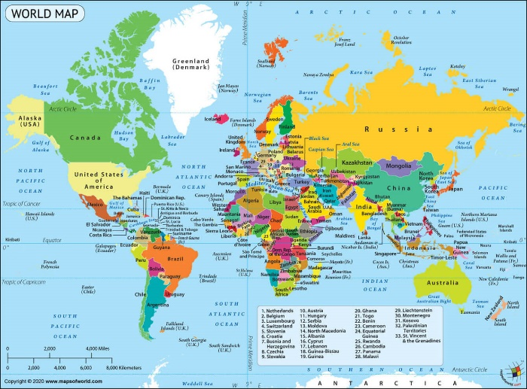
I am going to learn to:
- Explain the position and significance of the Equator, the Northern Hemisphere, and the Southern Hemisphere.
- Identify lines of latitude and longitude.
- Use longitude and latitude to find places on maps, atlases and globes.
- Describe the key features of the Polar Regions and compare them to the UK.
- Compare the climate of the tropics with the UK climate.
- Explain the position and significance of the Prime Meridian.
- Explain the position and significance of time zones.

Things to look forward to:
- Use the internet to explore exciting places around the world and to zoom in on different places.
- Compare places to where we live.
- Explore artists from different countries.
- Learn about special places all around the world.
- Use a compass, globes and maps.
- Look at world weather and see how it compares in different countries.

Knowledge Planner
Y4 – Settlements, Local Geography
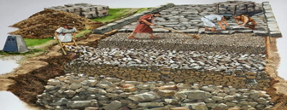
A Roman Road:
The Romans introduced the use of roads to us.
Land use patterns in the UK.
I am going to learn to:
- Explain why settlements develop in certain locations.
- Compare places. Which geographical features make places suitable areas in which to settle? Identify features such as hills, coasts and rivers on a map.
- Use Google Maps to compare land use in North Lincolnshire and other close counties. What do you notice about place names? What is the same? What is different Can you find any Roman settlements or Roman roads near us?
- Look at aerial view photographs and identify which places are urban and which are rural. How is land used?
- Compare urban and rural areas using four-figure grid references.
- Compare maps of different agricultural areas and explain why an area is suited to crop or livestock farming.

Things to look forward to:
- Settlement sorting game. What would a settler need to have? Use your power of persuasion to discuss which places would be best to settle in.
- Use Google maps to zoom in on aerial views of villages, towns and cities.
- Learn about what Roman roads were like and spot some near us using maps.
- Use a compass, globes and road atlases and maps.
Facts I will find useful:
- The Romans were an empire.
- The Romans conquered Britain after multiple unsuccessful attempts.
- Being a part of the Roman Empire is still evident in life today.
What I already need to know:
- The village my school is in is called Haxey, which is in North Lincolnshire. There are villages and towns in North Lincolnshire, some of which are coastal.
- North Lincolnshire is in England, which is a country. England, which is in the United Kingdom, is in the continent of Europe.
- Some land-use patterns of the UK.
- Use simple compass directions (North, South, East and West) and locational and directional language [for example, near and far; left and right], to describe the location of features and routes on a map.
- North Lincolnshire and South Yorkshire are counties in England.
National Curriculum Statements:
- To describe and understand key aspects of human geography, including: types of settlement and land use, economic activity, trade links, and the distribution of natural resources, energy, food, minerals and water in the context of the needs of early settlers and comparing land use in different settlements.
- To use maps, atlases, globes and digital/computer mapping to locate countries and describe features studied in the context of the origins of settlements.
- To use the eight points of a compass, four and six-figure grid references, symbols and key (including the use of Ordnance Survey maps) to build their knowledge of the United Kingdom and the wider world in the context of identifying links between settlements.

