National Curriculum Statements:  - Name and locate counties and cities of the United Kingdom, geographical regions and their identifying human and physical characteristics, key features including coasts  - Use the eight points of a compass, four and six-figure grid references, symbols and key (including the use of Ordnance Survey maps) to build their knowledge of the United Kingdom and the wider world | What I already need to know:  - Knowledge of UK maps  - Knowledge of World Maps  - Able to read and place co-ordinates.
I am going to learn to:  - Idenitfy locations in the UK with place names of Anglo Saxon origin.  - Learn how to use 4 figure grid references and apply these to map reading.  - Learn how to use 6 figure grid references and apply these to map reading. | Key Vocabulary: Location, place, settlement physical feature, human feature, grid reference, ordnance survey, north, south, east, west, compass, direction.
Things to look forward to:  Finding out the origin of the names of places local to us. | 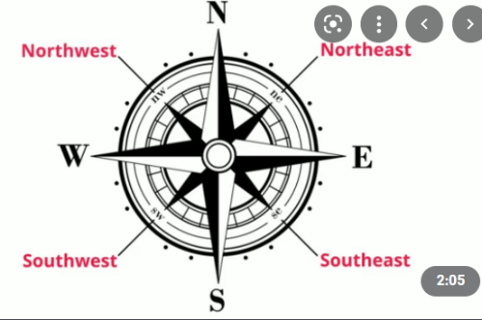  Facts I will find useful:

Year 5 – Geography – Using Maps
National Curriculum Statements:  - Name and locate counties and cities of the United Kingdom, geographical regions and their identifying human and physical characteristics, key features including coasts  - Use the eight points of a compass, four and six-figure grid references, symbols and key (including the use of Ordnance Survey maps) to build their knowledge of the United Kingdom and the wider world | What I already need to know:  - Knowledge of UK maps  - Knowledge of World Maps  - Able to read and place co-ordinates.
I am going to learn to:  - Idenitfy locations in the UK with place names of Anglo Saxon origin.  - Learn how to use 4 figure grid references and apply these to map reading.  - Learn how to use 6 figure grid references and apply these to map reading. | Key Vocabulary: Location, place, settlement physical feature, human feature, grid reference, ordnance survey, north, south, east, west, compass, direction.
Things to look forward to:  Finding out the origin of the names of places local to us. | Facts I will find useful:

Year 5 – Geography – Energy and the Environment

National Curriculum Statements:  - Human Geography: To describe types of settlement and land use, economic activity including trade links, and the distribution of natural resources including energy, food, minerals and water in the context of what settlers need , the context of renewable and non-renewable energy sources and food miles.  - Use maps, atlases, globes and digital mapping to locate countries and describe features  - Name and locate counties and cities of the United Kingdom, geographical regions and their identifying human and physical characteristics, key features including coasts | What I already need to know:  - Knowledge of UK maps  - Knowledge of World Maps  - Know what a settlement is
I am going to learn to:  - Identify some of Britain’s natural resources and explain how they are used.  - Identify how every settlement which has ever existed has needed resources in order to survive (link back to Stone Age/Saxons etc)  - Identify some ways in which natural resources are used to produce energy.  - Identify clean and renewable natural resources used to produce electricity, and to discuss the pros and cons of their use.  - To identify parts of the world where wood is produced, and consider some of the problems associated with its production.  - To know where and how steel is produced.  - To know where and how glass and concrete are produced in Britain using natural resources.  - To describe where a range of natural resources come from and how they are used. | Key Vocabulary: Power station, generated, renewable, economic, sustainable, turbine, solar panel, settlement, distribution port, coast, supply, conserve, hydro- electricity, trade, steel, glass, manufacturing, economy

Year 5 – Geography – Coast Comparison

National Curriculum Statements:  - Geographical skills and fieldwork ▪ use maps, atlases, globes and digital/computer mapping to locate countries and describe features studied ▪ use the eight points of a compass, four and six-figure grid references, symbols and key (including the use of Ordnance Survey maps) to build their knowledge of the United Kingdom and the wider world ▪ use fieldwork to observe, measure, record and present the human and physical features in the local area using a range of methods, including sketch maps, plans and graphs, and digital technologies.  - Human and Physical Geography To name and locate counties and cities of the United Kingdom,geographical regions and their identifying human and physical characteristics, key topographical features (including hills, mountains, coasts and rivers), and land-use patterns; and understand how some of these aspects have changed over time,  in the context of locating Whitby and Haxey. | What I already need to know:  - The names and location of counties and cities of the United Kingdom, identifying some human and physical characteristics including hills, mountains, rivers and seas, and how a place has changed.  - Know a range of significant human and physical features. Explain how some physical features have formed and how they can change.  - Explain the impact of humans on the earth in terms of land use, settlements and their connection to physical changes.  Key Vocabulary: Physical, human, processes, formation, landscapes, environments, coast, erosion, diagrams, globes, aerial photographs, economic, trade links, Geographical Information Systems. Southern/Northern Hemisphere

I am going to learn what coasts are and to compare a coastal town to Haxey:
*Where Is Whitby? Where is Haxey? I will use digital and paper maps to name and locate counties and cities of the UK.
What Is the Landscape in the areas round Whitby and Haxey? How is the land used?
Compare the physical geography of Whitby with that of my own area: Haxey. I will be able to explore images of contrasting landscapes
from a variety of sources.
3. What is a coast? Research the location and features of coastal towns. Research a coastal town in Eastern Europe.
Enjoy researching using Google Maps. Present information to others.

4. What Goes On in Whitby? Compare with local area.

Compare the human geography of Whitby with that of Haxey

5. Whitby or Haxey: A Travel Guide.
Create a travel guide for a trip to Whitby..

6. What might Whitby be like in the future?
Explore the idea of coastal erosion. What could be done to prevent it?

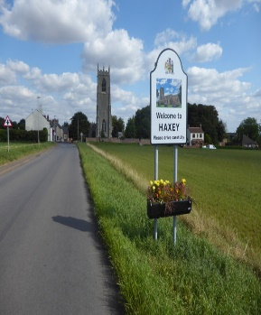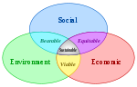
Things to look forward to: Using Google Maps to explore where we live and to compare to features in coastal areas. Make a tourism guide.

