
Year 6 – Geography - South America

National Curriculum Statements:  Continents, Countries and Cities  - To use maps, atlases, globes and digital/computer mapping to  locate countries and describe features studied in the context of North and  South America.  - To locate the world’s countries, using maps to focus on Europe  (including the location of Russia) and North and South America,  concentrating on their environmental regions, key physical and  human characteristics, countries, and major cities in the context  of places in North and South America.  Location, Location  - Identify the position and significance of latitude, longitude,  Equator, Northern Hemisphere, Southern Hemisphere, the Tropics  of Cancer and Capricorn, Arctic and Antarctic Circle, the Prime/  Greenwich Meridian and time zones (including day and night) in  the context of identifying and describing a range of places across  the Americas.  Weather and Climate  - Describe and understand key aspects of physical geography,  including: climate zones, biomes and vegetation belts, rivers,  mountains, volcanoes and earthquakes, and the water cycle in the  context of comparing how weather and climate across South America is  affected by geographical location.  Comparing Places – UK Fieldwork  - Use fieldwork to observe, measure and record the human and  physical features in the local area using a range of methods,  including sketch maps, plans and graphs and digital technologies  in the context of undertaking fieldwork to identify human and  physical features of the local area.  Comparing Places – North America  - Understand geographical similarities and differences through the  study of human and physical geography of a region of the United  Kingdom […] and a region within North or South America in the  context of comparing human and physical features of the local  area with a region of North America. | What I already need to know:  - The names and locations of the continents in the World  - What is meant by physical and human features in geography  - Different types of settlement  - What is meant by natural resources: energy, food, minerals and water  - Be able to use an atlas and maps to identify countries and physical and human features.
I am going to learn:
- To locate and name the countries of South America.
- To describe the climates and biomes of different regions
across South America.
- To use geographical terminology to describe the location and characteristics of a range of places across South America.
- To identify physical and human geographical features of
my local area.
- To identify similarities and differences in the human and physical geography of my local area and a region of South America.
- The names and locations of the ancient and new wonders of the world in South America
- To describe the characteristics and significance of a
natural wonder of the Americas.

Key Vocabulary:
Human and physical features, latitude, longitude, Equator, Northern and Southern Hemisphere, The Topics of Cancer and Capricorn, climate zones, biomes, vegetation belts, economic activity, natural resources, Amazon,

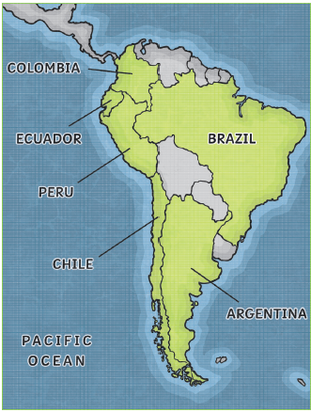

Things to look forward to:
Learning about the flora and fauna of The Rainforest
Artwork – 3D, collage
Presentations of own project to the class.
Facts I will find useful:
- The major countries of South America include Brazil, Colombia, Argentina, Chile, Peru and Ecuador.
- South America is the fourth largest continent in the world. It is bordered by the Atlantic Ocean to the east and the Pacific Ocean to the west.
- It is connected to North America by the region of Central America. Important geographical features include the Amazon Rainforest and the Andes Mountains.
- The main industries are: Farming, Mining, Ranching, Winemaking, Brewing, Drugs, Construction, Oil Production & Refining, Cut Flowers, Tourism, Steelmaking, Aircraft Manufacturing
- The Amazon is referred to as the "Lungs of the Earth", and with good reason. More than 20% of the world's oxygen is produced there.
- Brazil is the largest country and covers almost half the continent. It is only slightly smaller than the USA.
- South America’s largest river is the Amazon, which is the second longest river in the world. However, the Amazon carries more water than any other river in the world.
- The Incas were the largest group of indigenous people in South America when the Europeans arrived.

Year 6 – Geography - Rivers

National Curriculum Statements:  - To describe and understand key aspects of rivers and the water cycle.  - To name and locate key topographical features (including hills, mountains, coasts and rivers), and land-use patterns; and understand how some of these aspects have changed over time.  - To describe and understand key aspects of human geography, including: types of settlement and land use, economic activity including trade links, and the distribution of natural resources including energy, food, minerals and water.  - To use maps, atlases, globes and digital/computer mapping to locate countries and describe features studied  - To use the eight points of a compass, four and six-figure grid references, symbols and key (including the use of Ordnance Survey maps) to build their knowledge of the United Kingdom and the wider world  - To use fieldwork to observe, measure, record and present the physical features in the local area using a range of methods, including sketch maps, plans and graphs, and digital technologies. | What I already need to know:  - To have a knowledge of the countries which form United Kingdom  - To use a map to locate Lincolnshire and Yorkshire  - Some physical and geographical features of your area.  - To use four-figure grid references on an OS map.  - To identify and understand some OS symbols.
I am going to learn:
- To explain the water cycle.
- To locate some of the main rivers of the world.
- To describe the key features of a river system.
- To use atlases, aerial photographs and maps to identify the key features of a river system.
- To describe the ways rivers are used.
- To explain the impact of damming rivers.
- To study the Rivers Trent and Humber in our locality.

Key Vocabulary:
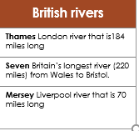
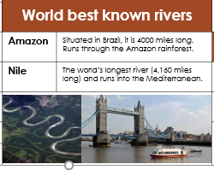
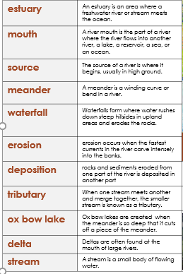
Facts I will find useful:

