
Knowledge Planner
Y1 – DT – Mechanisms
National Curriculum Statements:  Design  - Design purposeful, functional, appealing products for themselves and other users based on design criteria  - Generate, develop, model and communicate their ideas through talking, drawing templates, mock –ups.  Make  - Select from and use a range of tools and equipment to perform practical tasks – cutting, shaping, joining and finishing.  - Select from and use a wide range of materials and components, including construction materials.  Evaluate  - Explore and evaluate a range of vehicles.  - Evaluate their ideas and products, against a design criteria.  Technical  - Build structures, exploring how they can be made stronger, stiffer and more stable.  - Explore and use mechanisms – wheels, axles | Things I need to already know:  ELG  - How to handle equipment and tools effectively - scissors  - Children safely use and explore a variety of materials, tools and techniques, experimenting with colour, design, texture, form and function – cardboard, boxes, tissue paper, straws. Learn how to join two materials together using tape or glue  - Children use what they have learnt about media and materials in original ways, thinking about uses and purposes. They represent their own ideas, thoughts and feelings through design and tech, art
I am going to learn to:  - Develop the creative, technical and practical expertise needed to make a moving vehicle.  - Key vocabulary – wheels, axles,  - The process we need to go through to make a product – design, make, evaluate.  - Join materials using glue and tape  - Cut dowel safely to a required length | 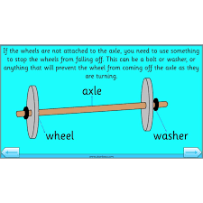  Exploring and designing - Labelling and joining  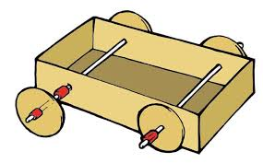Making - Main structure 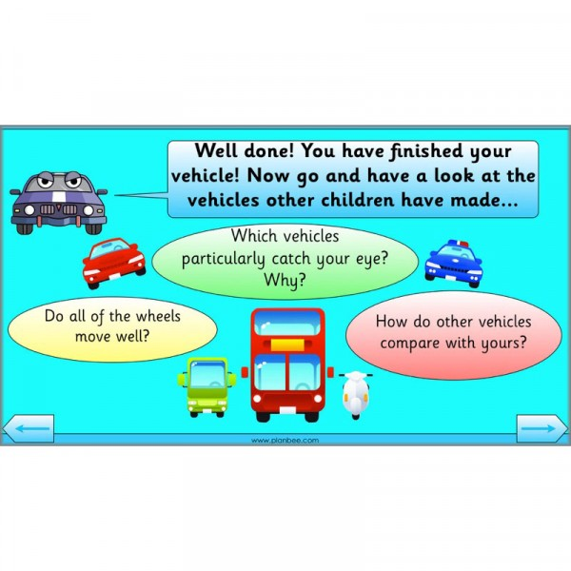 Evaluating
Things to look forward to:  - Building a prototype using a construction kit  - Explore a range of wheels – sizes, materials  - Design a moon buggy according to a design criteria  - Making a moon buggy – cutting dowel, joining materials and using finishing techniques  - Testing a product for purpose  - Evaluate a product according to design criteria | Facts I might find useful:  - Space Buggies are called Luna Rovers  - They were designed to help Astronauts explore further on the moon as they can not walk very far in their bulky spacesuits.  - Three Luna Rovers have been taken to the moon and left there-they are still there!  - The Luna Rover uses the sun to help it navigate where to go.  - The Lunar Rover was specially designed to travel in low gravity on the soft surface on the moon- it was tested on sand!  - It has a large dish antenna to send pictures back to earth.  - That an axle is needed to make a vehicle move.

