DT National Curriculum Statements:  Design  - Design purposeful, functional, appealing products for themselves and other users based on design criteria.  - Generate, develop, model and communicate their ideas through talking and mock-ups.  Make  - Select from and use a range of tools and equipment to perform practical tasks (for example, cutting, shaping, joining, and finishing.)  - Select from and use a wide range of materials and components, including textiles, according to their characteristics.  Evaluate  - Explore and evaluate a range of existing products.  - Evaluate their ideas and products against design criteria. | What I already need to know:  - How to make a simple plan of what I am going to create. (Y1)  - How to measure how much of a material I need. (Y1)  - How to join materials together simply. (FS2 and Y1)
I am going to learn to:
Take inspiration from design throughout history
- Explore designs from different puppets and puppeteers, including how they move and what they are made from.
- Julie Taymoor (The Lion King)
- The Handspring puppet company - Adrian Kohler and Basil Jones(War Horse)
- Bonnie Erickson (The Muppets)
Master practical skills
- Cut materials safely using tools provided.
- Shape textiles using templates.
- Join textiles using running stitch.
- Colour and decorate textiles using a number of techniques.
Design, make, evaluate and improve
- Make a finger puppet using a template.
- Sew using a simple running stitch.
- Draw my design and plan the materials that I will need.
- Use different methods of joining fabric to create my own glove puppet.
- Decorate my puppet using buttons and fabric.
- Evaluate my finished puppet.

Cross-Curricular Links: Art – textiles
- Sewing my own fabric glove puppet.

Key Vocabulary:
Template, needle, pin, sewing, thread, marionette, and felt.

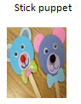
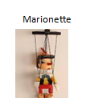
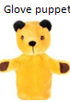
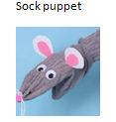
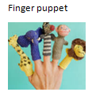
Facts I will find useful:

G

Things to look forward to:
- Sewing my own Christmas themed glove puppet.
- Creating puppet shows in the role play area.
- Watching some video clips of puppet shows. (eg. The Muppet Show, The Sound of Music)

