DT National Curriculum Statements:  Design  - Use research and develop design criteria to inform the design of innovative, functional, appealing products that are fit for purpose, aimed at particular individuals or groups  - generate, develop, model and communicate their ideas through discussion, annotated sketches, cross-sectional and exploded diagrams, prototypes, pattern pieces and computer-aided design  Make  - select from and use a wider range of tools and equipment to perform practical tasks [for example, cutting, shaping, joining and finishing], accurately  - select from and use a wider range of materials and components, including construction materials, textiles and ingredients, according to their functional properties and aesthetic qualities  Evaluate  - investigate and analyse a range of existing products  - evaluate their ideas and products against their own design criteria and consider the views of others to improve their work  - understand how key events and individuals in design and technology have helped shape the world  Food and Nutrition  - understand and apply the principles of a healthy and varied diet  - prepare and cook a variety of predominantly savoury dishes using a range of cooking techniques  - understand seasonality, and know where and how a variety of ingredients are grown, reared, caught and processed. | What I already need to know:  - Cut, peel and grate ingredients safely and hygienically (Y1/2)  - Measure or weigh using measuring cups or electronic scales (Y1/2)  - Assemble or cook ingredients (Y1/2)  - Prepare ingredients hygienically using appropriate utensils (Y3/4)  - Measure ingredients to the nearest gram accurately (Y3/4)  - Follow a recipe (Y3/4)  - Assemble or cook ingredients – controlling the temperature of the oven or hob (Y3/4)
I am going to learn to:
Take inspiration from design throughout history
- Combine elements of recipes from a range of inspirational chefs throughout history
- Research traditional Anglo-Saxon pies
- Create innovative designs that improves upon existing products
- Evaluate the design of products so as to suggest improvements to the user experience
Master practical skills
- Understand the importance of correct storage and handling of ingredients
- Measure accurately and calculate ratios of ingredients to scale up or down from a recipe
- Demonstrate a range of baking and cooking techniques
- Create and refine recipes, including ingredients, methods, cooking times and temperatures
Design, make, evaluate and improve
- Design a sweet or savoury pie with the user in mind, motivated by the service a product will offer
- Make a sweet or savoury pie through stages of prototypes, making continual refinements
- Ensure that the pie has a high quality finish, using art skills where appropriate
- Use prototypes and cross-sectional diagrams to represent designs
- Evaluate the end product and identify areas to be improved upon

Cross-Curricular Links: Maths and science
- Measuring ingredients using scales.
- Healthy eating.

Key Vocabulary:
Recipe, ingredients, hygienic, sweet, savoury, micro-organisms, quantity

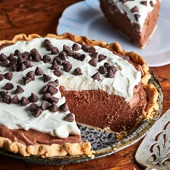
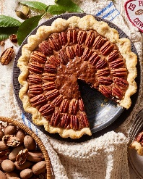
Facts I will find useful:

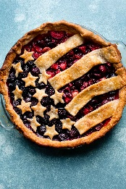
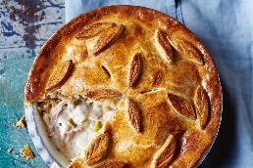
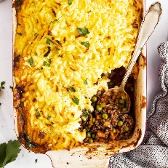
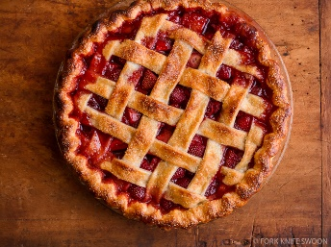
Things to look forward to:
- Taste testing a variety of sweet and savoury pie crusts.
- Cooking and eating your own sweet or savoury Anglo Saxon inspired pie.

