
Knowledge Planner Y6 DT – Textiles (Cushion Cover)

DT National Curriculum Statements:  Design  - use research and develop design criteria to inform the design of innovative, functional, appealing products that are fit for purpose, aimed at particular individuals or groups  - generate, develop, model and communicate their ideas through discussion, annotated sketches, cross-sectional and exploded diagrams, prototypes, pattern pieces and computer-aided design  Make  - select from and use a wider range of tools and equipment to perform practical tasks [for example, cutting, shaping], accurately  - select from and use a wider range of materials and ingredients, according to their functional properties and aesthetic qualities  Evaluate  - investigate and analyse a range of existing products  - evaluate their ideas and products against their own design criteria and consider the views of others to improve their work  - understand how key events and individuals in design and technology have helped shape the world | What I already need to know:  - The need for a seam allowance.  - Join textiles with appropriate stitching. (Y3 cross stitch, Y4 back stitch)  - Select the most appropriate techniques to decorate textiles.  Key Vocabulary:  Seam allowance, applique, fasteners, aesthetics, strength, durability, practicality, style
I am going to learn to:  Take inspiration from design throughout history  - Combine elements of design from a range of inspirational designers throughout history, giving reasons for choices. (eg chefs,links to careers.)  - Create innovative designs that improve upon existing products.  - Evaluate the design of products so as to suggest user experience.  - Mary White Terence Conran  Master practical skills  - Create objects (such as a cushion) that employ a seam allowance.  - Join textiles with a combination of stitching techniques. (Y5 overcast stitch, Y6 blanket stitch)  - Use the qualities of materials to create suitable visual and tactile effects in the decoration of textiles (such as a soft decoration for comfort on a cushion.)  Design, make, evaluate and improve  - Design with the user in mind, motivated by the service a product will offer (rather than simply for profit.) - comfort, functionality  - Make products through stages of prototypes, making continual refinements.  - Ensure products have a high quality finish, using art skills where appropriate.  - Use prototypes. Cross sectional diagrams and computer aided designs to represent designs.  - Evaluate my cushion  Cross Curricular Links:  - Art – printing and sewing | Facts I will find useful:  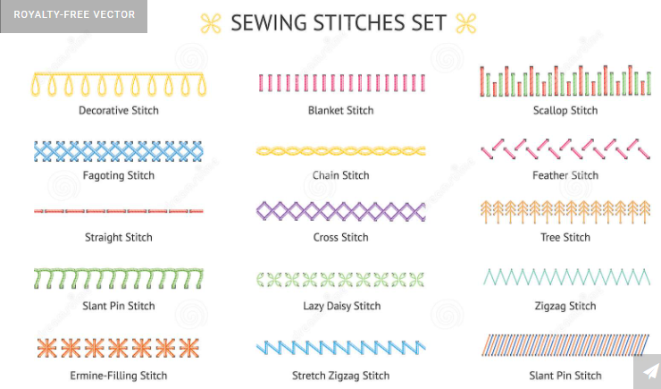  Things to look forward to:  - Designing and making my own cushion

