Knowledge Planner

Y1 – Science and Geography – Seasonal Changes

National Curriculum Statements:  - To observe changes across the four seasons.  - To observe and describe weather associated with the seasons and how the length of day varies.  - Identify seasonal and daily weather patterns in the United Kingdom.  Working Scientifically  - Asking simple questions and recognising that they can be answered in different ways.  - Observing closely, using simple equipment.  - Performing simple tests.  - Using their observations and ideas to suggest answers to questions.  - Gathering and recording data to help in answering questions. | Things I need to know already:  - Awareness of the features of the immediate environment and how environments might vary from one another.  - Make observations of animals and plants and explain why some things occur, and talk about changes.
I am going to learn to:  - Name the seasons of the year.  - Identify how the weather is different in the different seasons.  - Observe changes through the different seasons.  - Identify what happens to a tree through the different seasons.  - Explore how the length of day changes throughout the year.  Things to look forward to:  - Looking for signs of the different seasons in the local environment.  - Looking for signs of autumn on a visit.  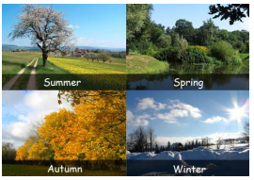 | Facts I might find useful:  - There are 4 seasons – spring, summer, autumn and winter.  - There are more hours of daylight in the summer than there are in winter.
  Vocabulary
  Seasons (Spring, Summer, Autumn, Winter) | The 4 divisions of the year.
  Weather | The state of the atmosphere at a particular place and time.
  Weather Forecast | A statement saying what the weather will be like.
  Rain | Water that falls from clouds in small drops.
  Sun | A star that provides light and heat to the Earth.
  Wind | A current of air moving across the earth’s surface.
  Snow | Small, soft pieces of ice that fall from the sky when it is cold.
  Hail | Hard pieces of ice that fall from the sky when it is cold.
  Sleet | A mixture of rain and snow.
  Temperature | The measured amount of heat in a place.

Knowledge Planner

Y1 – Science – Animals including Humans (Human)

National Curriculum Statements:  - Identify, name, draw and label the basic parts of the human body and say which part of the body is associated with each sense.  - Use their observations and ideas to suggest answers to questions.  Working Scientifically  - Asking simple questions and recognising that they can be answered in different ways.  - Observing closely, using simple equipment.  - Performing simple tests.  - Using their observations and ideas to suggest answers to questions.  - Gathering and recording data to help in answering questions. | Things I need to know already:  - That people have similarities and differences.  - Body control in both large and small movements.
I am going to learn to:  - Draw and label the main parts of the body.  - Identify the 5 senses.  - Describe which part of the body is associated with each sense.  - Explore using our senses to find out about the world around us.  Things to look forward to:  - Smelling and tasting tests.  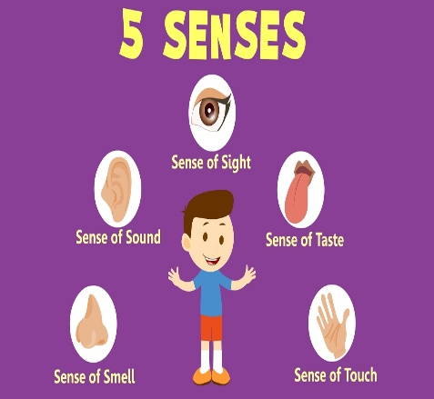 | Facts I might find useful:  - We have 5 senses – sight, hearing, taste, touch and smell.  - Our sense organs send messages to our brain.  - Some people need help with sight and hearing.  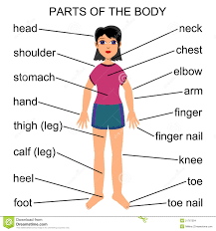
  Vocabulary
  Senses | How we find out about the world around us.
  Sight | Our eyes use light to help us to see.
  Hearing | Our ears help us to hear.
  Touch | We touch with our skin.
  Taste | Our tongue helps us to taste.
  Smell | We smell things with our nose.
  Skeleton | The structure of bones that support and hold up our bodies.

Knowledge Planner

Y1 – Science - Materials

National Curriculum Statements:  - Distinguish between an object and the material from which it is made.  - Identify and name a variety of everyday materials, including wood, plastic, glass, metal, water and rock.  - Describe the simple physical properties of a variety of everyday materials.  - Compare and group together a variety of everyday materials on the basis of their physical properties.  - Asking simple questions and recognising that they can be answered in different ways.  - Performing using simple tests.  Working Scientifically  - Asking simple questions and recognising that they can be answered in different ways.  - Observing closely, using simple equipment.  - Performing simple tests.  - Using their observations and ideas to suggest answers to questions.  - Gathering and recording data to help in answering questions.  Facts I might find useful:  - The word material in science refers to what an object is made of, it does not just mean fabric.  - Materials have different properties and therefore are suitable for different jobs. | Things I need to know already:  - There are similarities and differences between objects and materials.  - Talk about the features of their own immediate environments.  Things to look forward to:  - Experiments involving testing different properties of materials, such as waterproofing and absorbency.  - Exploring the different materials that toys are made out of.  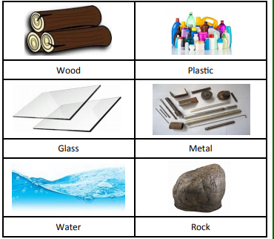
I am going to learn to:  - Identify what different objects are made from.  - Describe the properties of different materials.  - Sort a selection of materials according to their physical properties.  - Perform simple experiments to test materials to for different purposes.  - Explain why different toys are made from different materials.
  Vocabulary
  Waterproof | A material that will not let liquid through.
  Absorbent | A material that soaks up liquid.
  Transparent | A material that you can see through, such as glass.
  Opaque | A material that you cannot see through.
  Material | The ‘stuff’ an object is made out of.
  Liquid | Liquids can flow and be poured easily.
  Properties | A way to describe something.
Knowledge Planner

Y1 – Science - Animals including Humans (Animals)

National Curriculum Statements:  - Identify and name a variety of common animals including fish, amphibians, reptiles, birds and mammals.  - Identify and name a variety of common animals that are carnivores, herbivores and omnivores.  - Describe and compare the structure of a variety of common animals, including pets.  - Identifying and classifying.  Working Scientifically  - Asking simple questions and recognising that they can be answered in different ways.  - Observing closely, using simple equipment.  - Performing simple tests.  - Using their observations and ideas to suggest answers to questions.  - Gathering and recording data to help in answering questions. | Things I need to know already:  - Know about similarities and differences in relation to living things.  - Make observations of animals and plants and explain why some things occur, and talk about changes.  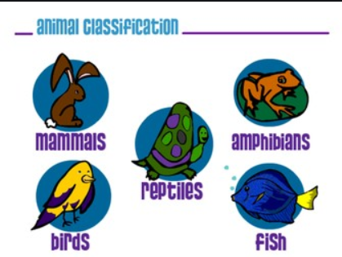
I am going to learn to:  - Describe the different classifications of animals.  - Sort animals into different groups.  - Describe the structures of different animals.  - Identify which animals live in different habitats.  - Describe what animals need to stay alive.  Things to look forward to:  - Searching for minibeasts.  - Finding out about lots of different animals.  Facts I might find useful:  - Animals can be sorted into different groups according to different characteristics.  - All animals need food, water and shelter to stay alive and healthy.
  Vocabulary
  Mammal | An animal that feeds its young with milk and has skin with hair.
  Bird | An animal with feathers, wings and a beak that is usually able to fly.
  Reptile | An animal that has dry, scaly skin and lays eggs on land.
  Amphibian | An animal which can live on land or in water.
  Fish | An animal with gills and fins that lives in water.
  Invertebrates | An animal without a backbone.
  Carnivore | An animal that eats meet.
  Herbivore | An animal that eats plants.
  Omnivore | An animal that eats both meat and plants.
Knowledge Planner

Y1 – Science - Plants

National Curriculum Statements:  - Identify and name a variety of common wild and garden plants, including deciduous and evergreen trees.  - Identify and describe the basic structure of a variety of common flowering plants, including trees.  - Observe the growth of flowers and vegetables they have planted.  - Observe closely, using simple equipment.  - Gathering and recording data to help in answering questions.  Working Scientifically  - Asking simple questions and recognising that they can be answered in different ways.  - Observing closely, using simple equipment.  - Performing simple tests.  - Using their observations and ideas to suggest answers to questions.  - Gathering and recording data to help in answering questions. | Things I need to know already:  - Know about similarities and differences in relation to living things.  - Make observations of animals and plants and explain why some things occur, and talk about changes.  Things to look forward to:  - Bean growing competition.  - Growing vegetables outside the classroom.
I am going to learn to:  - Identify and name a variety of plants.  - Identify and describe the parts of flowers and plants.  - Describe different types of trees.  - Observe and describe the growth of plants.  - Record data relating to the growth of plants.  - Identify what plants need to stay alive and healthy.  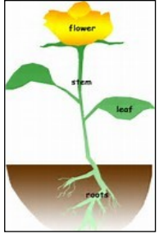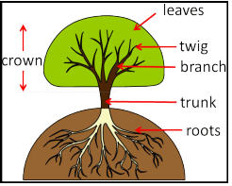 | Facts I might find useful:  - The main parts of a plant are flower, stem, leaves and roots.  - The man parts of a tree are trunk, branches, twigs, leaves, roots and bark.  - Plants need water, sunlight and nutrients to grow.
  Vocabulary
  Root | The part of a plant that is underground.
  Seed | The part of a flowering plant that can develop into a new plant.
  Evergreen | A tree that keeps its leaves all year round.
  Deciduous | A tree that loses its leaves in the autumn and grows new ones in the spring.
  Bark | The outer covering of the trunk of a tree.
  Shoot | The first part of the plant’s stem to grow from a seed.

